**Create a Spring Web Project using Maven**

**Codes:**

**SpringLearnApplication.java:**

**package** com.cognizant.spring_learn;

**import** org.springframework.boot.SpringApplication;

**import** org.springframework.boot.autoconfigure.SpringBootApplication;

@SpringBootApplication

**public** **class** SpringLearnApplication {

**public** **static** **void** main(String[] args) {

System.***out***.println("Main method started...");

SpringApplication.*run*(SpringLearnApplication.**class**, args);

System.***out***.println("Aplication running");

}

}

**pom.xml:**

<?xml version="1.0" encoding="UTF-8"?>

<project xmlns="http://maven.apache.org/POM/4.0.0" xmlns:xsi="http://www.w3.org/2001/XMLSchema-instance"

xsi:schemaLocation="http://maven.apache.org/POM/4.0.0 https://maven.apache.org/xsd/maven-4.0.0.xsd">

<modelVersion>4.0.0</modelVersion>

<parent>

<groupId>org.springframework.boot</groupId>

<artifactId>spring-boot-starter-parent</artifactId>

<version>2.7.18</version>

<relativePath/> <!-- lookup parent from repository -->

</parent>

<groupId>com.cognizant</groupId>

<artifactId>spring-learn</artifactId>

<version>0.0.1-SNAPSHOT</version>

<name>spring-learn</name>

<description>Demo project for Spring Boot</description>

<url/>

<licenses>

<license/>

</licenses>

<developers>

<developer/>

</developers>

<scm>

<connection/>

<developerConnection/>

<tag/>

<url/>

</scm>

<properties>

<java.version>1.8</java.version>

</properties>

<dependencies>

<dependency>

<groupId>org.springframework.boot</groupId>

<artifactId>spring-boot-starter-web</artifactId>

</dependency>

<dependency>

<groupId>org.springframework.boot</groupId>

<artifactId>spring-boot-devtools</artifactId>

<scope>runtime</scope>

<optional>true</optional>

</dependency>

<dependency>

<groupId>org.springframework.boot</groupId>

<artifactId>spring-boot-starter-test</artifactId>

<scope>test</scope>

</dependency>

</dependencies>

<build>

<plugins>

<plugin>

<groupId>org.springframework.boot</groupId>

<artifactId>spring-boot-maven-plugin</artifactId>

</plugin>

</plugins>

</build>

</project>  
**Output:**

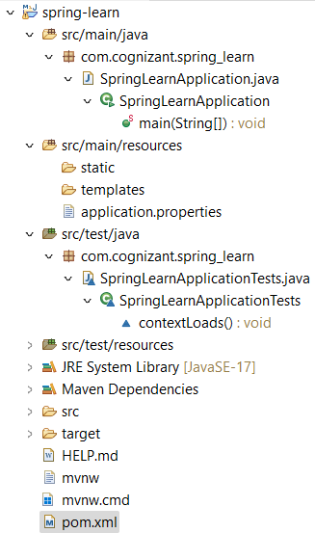

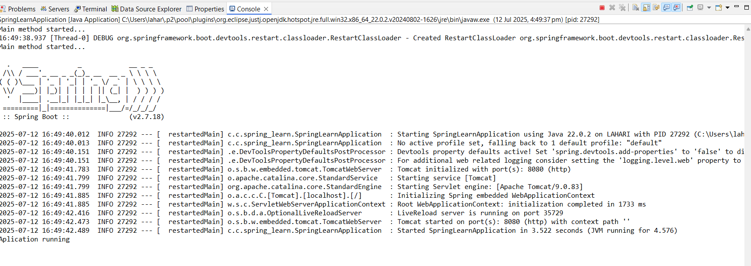

**Spring Core – Load Country from Spring Configuration XML**

**Codes:**

**Country.java:**

**package** com.cognizant.spring_learn;

**import** org.slf4j.Logger;

**import** org.slf4j.LoggerFactory;

**public** **class** Country {

**private** **static** **final** Logger ***LOGGER***=LoggerFactory.*getLogger*(Country.**class**);

**private** String code;

**private** String name;

**public** Country() {

***LOGGER***.debug("Inside Country Constructor");

}

**public** String getCode() {

***LOGGER***.debug("Getting country code");

**return** code;

}

**public** **void** setCode(String code) {

***LOGGER***.debug("Setting country code");

**this**.code=code;

}

**public** String getName() {

***LOGGER***.debug("Getting country name");

**return** name;

}

**public** **void** setName(String name) {

***LOGGER***.debug("Setting country name");

**this**.name=name;

}

@Override

**public** String toString() {

**return** "Country [code="+code+",name="+name+"]";

}

}

**SpringLearnApplication.java:**

**package** com.cognizant.spring_learn;

**import** org.slf4j.Logger;

**import** org.slf4j.LoggerFactory;

**import** org.springframework.context.ApplicationContext;

**import** org.springframework.context.support.ClassPathXmlApplicationContext;

**public** **class** SpringLearnApplication {

**private** **static** **final** Logger ***LOGGER***=LoggerFactory.*getLogger*(SpringLearnApplication.**class**);

**public** **static** **void** main(String[] args) {

***LOGGER***.info("Main method started...");

*displayCountry*();

}

**public** **static** **void** displayCountry() {

ApplicationContext context = **new** ClassPathXmlApplicationContext("country.xml");

Country country = (Country) context.getBean("country", Country.**class**);

***LOGGER***.debug("Country : {}", country.toString());

}

}

**country.xml:**

<?xml version="1.0" encoding="UTF-8"?>

<beans xmlns="http://www.springframework.org/schema/beans"

xmlns:xsi="http://www.w3.org/2001/XMLSchema-instance"

xsi:schemaLocation="http://www.springframework.org/schema/beans

https://www.springframework.org/schema/beans/spring-beans.xsd">

<bean id="country" class="com.cognizant.spring_learn.Country">

<property name="code" value="IN" />

<property name="name" value="India" />

</bean>

</beans>

**Output:**

